|  |  |  |  |
| --- | --- | --- | --- |
| 1 | | 54,984.0 | |
| NUMERO DE FRONTERAS | | ENERGIA AGREGADA | |
|  | | | |
| SI | | 31-12-2020 | |
| CONTRATO | | VENCIMIENTO CONTRATO | |
|  | | | |
| 34,566,816 | 36 | | 1,475,577 |
| INGRESO 2019 | DÍAS CERTIFICADOS 2019 | | ENERGIA RESPALDADA 2019 |
|  | | | |
| 429,306,924 | 214 | | 15,762,233 |
| INGRESO 2020 | DÍAS CERTIFICADOS 2020 | | ENERGIA RESPALDADA 2020 |
|  | | | |
| 150,153,732 | 118 | | 6,486,851 |
| INGRESO 2021 | DÍAS CERTIFICADOS 2021 | | ENERGIA RESPALDADA 2021 |

|  |
| --- |
| **COLOMBINA CAUCA**  USUARIO |

|  |
| --- |
| **Mateo Porras**  Ejecutivo de cuenta |

|  |
| --- |
| **Francisco Pizarro / Gerente de proyectos & Administración Energética / fpizarro@colombina.com**  Primera fecha: PUNTO FOCAL |

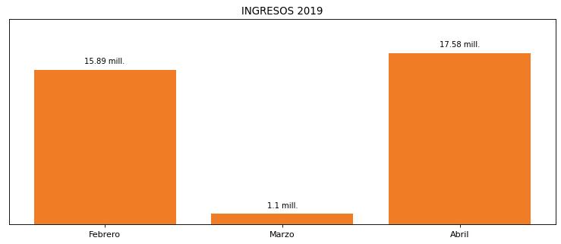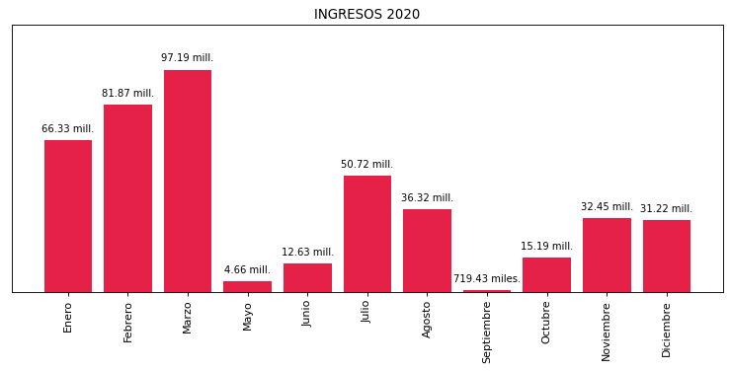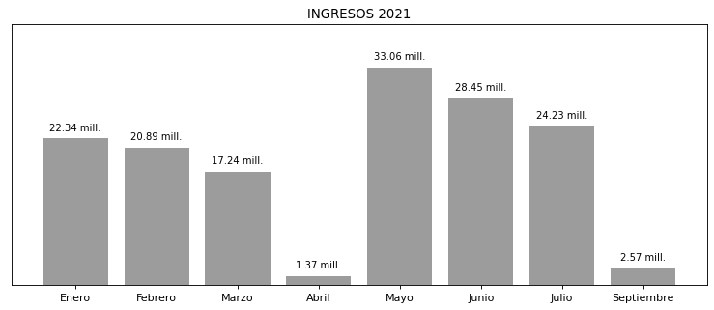

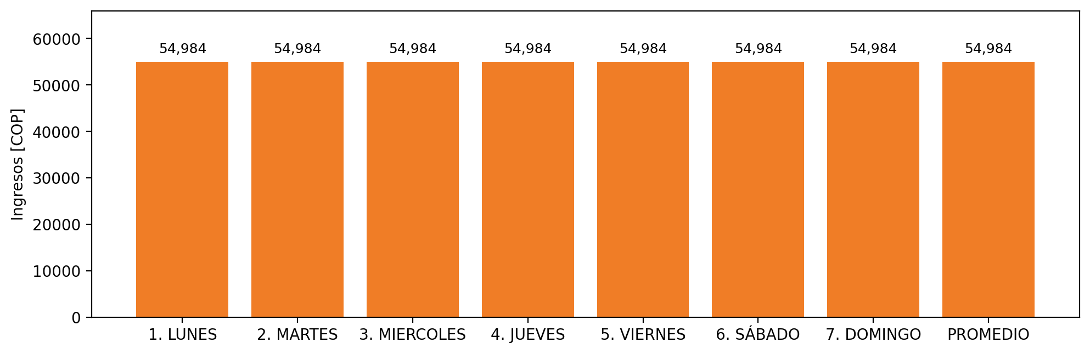

|  |  |  |  |  |  |  |  |  |  |
| --- | --- | --- | --- | --- | --- | --- | --- | --- | --- |
| **FRONTERA COMERCIAL** | **TIPO DDV** | **COD SIC** | **PREDIO** | **PROMEDIO** | **MARGEN** | **ÚLTIMA DESCONEXION** | **DÍAS CERTIFICADOS** | **ACTUALIZACION** | **PROXIMA PRUEBA DDV** |
| COLOMBINA DEL CAUCA S.A. | Frt35942 | Frt02994 | Prd01515 | 54,984 | NO APLICA | 2021-09-16 | 2.0 | 2023-04-15 | 2022-02-05 |